[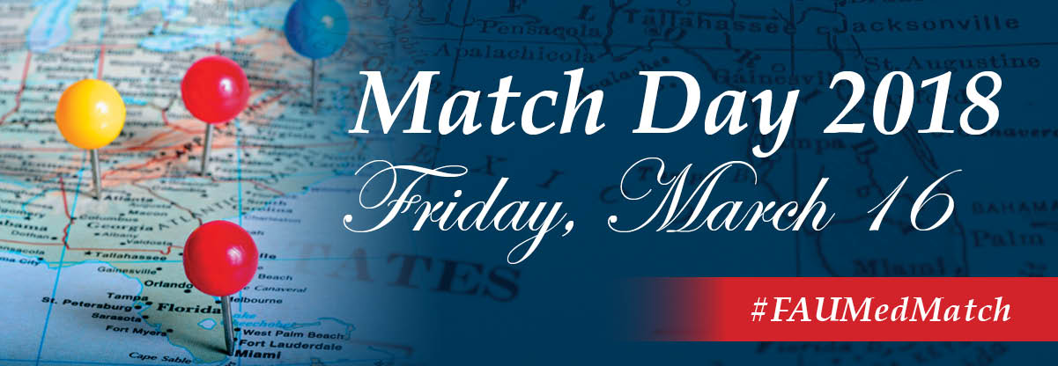](http://www.google.com/url?sa=i&rct=j&q=&esrc=s&source=images&cd=&cad=rja&uact=8&ved=0ahUKEwj-oomZq_HYAhUGbq0KHZUFD_gQjRwIBw&url=http://med.fau.edu/&psig=AOvVaw2aafInz7aOxWFve3xiv9Es&ust=1516908410512610)

**Prepare for residency match with these sessions:**

**Overview of the Match/ERAS — Wed., April 22nd**

**What’s Next? — Wed., April 29th**

**Personal Statement/CV/ LORs — Wed., May 13th**

**Program Directors’ Perspective — Wed., May 20th**

**Interviewing — Wed., Sept. 23rd**

**Mock Interviews — various dates in Sept. and Oct.\***

**Rank Order List – Wed., January 13th**

**Sessions Time: 12:00-12:50 pm**

**Sessions Location: Lecture Hall 124**

**(*times for mock interviews will vary)**

**The Road to Match**

